How to Run the MovieList Application

# Prerequisites:

* Python 3.6
* Django package for Python

# Step by step

1. The easiest way to get start with python is by installing Anaconda. Go to <https://www.anaconda.com/download/> and **download the Python 3.6 Version**

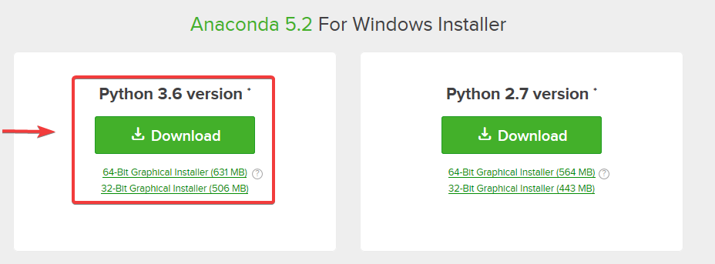

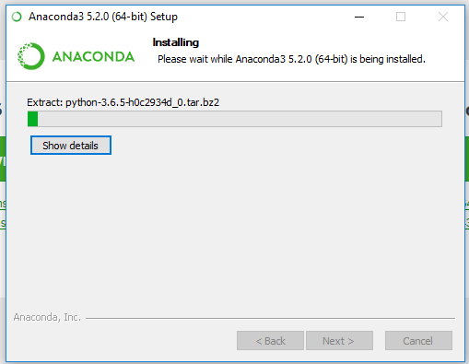

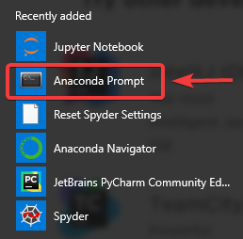2. Start Anaconda Prompt to install Django

3. Type ‘**conda install -c anaconda django’** into the console and press Enter

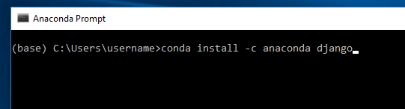

4. Type Y and press enter to confirm installation

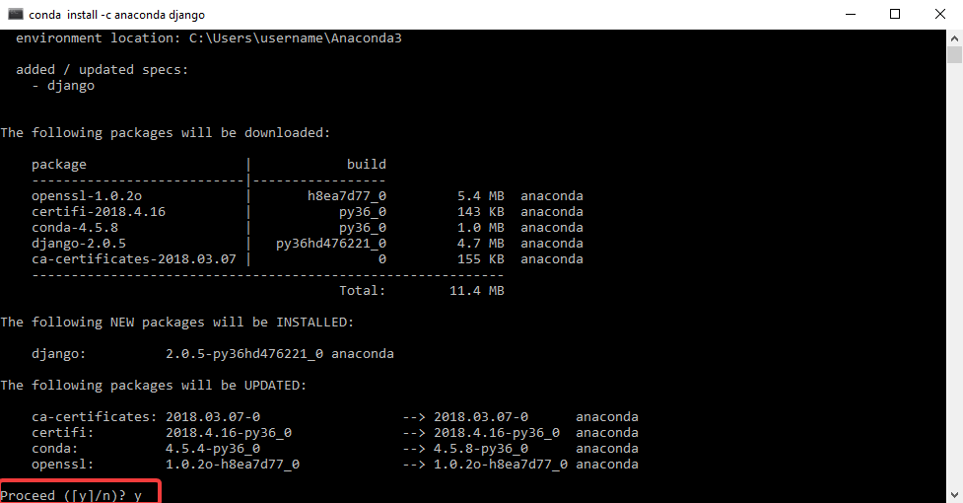

5. Change the directory of the console by typing **cd** and then the full path of the directory where the project is. For example, if you put the MovieRatings folder in the C: drive, then type ‘**cd C:\MovieRatings’**

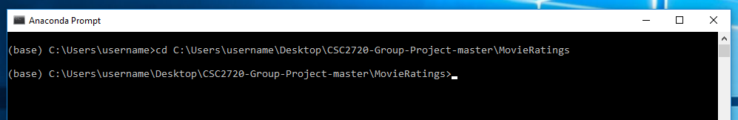

6. Once you are in the MovieRatings folder, type **python manage.py runserver** and the server will start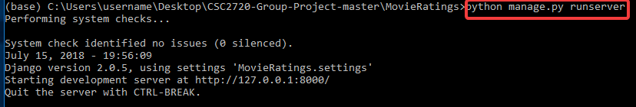

7. You can access the server using any modern web browser by typing this into your address bar:

[**http://127.0.0.1:8000**](http://127.0.0.1:8000)



8. You should now be able to use the application

